**Inside one of the subnets, create a VM and deploy MVC application code inside it and it should leverage the database on the Azure cloud (MVC application that you have created in your Asp.Net session)**

1.Select Virtual Machine from the Azure Portal and Add Virtual Machine

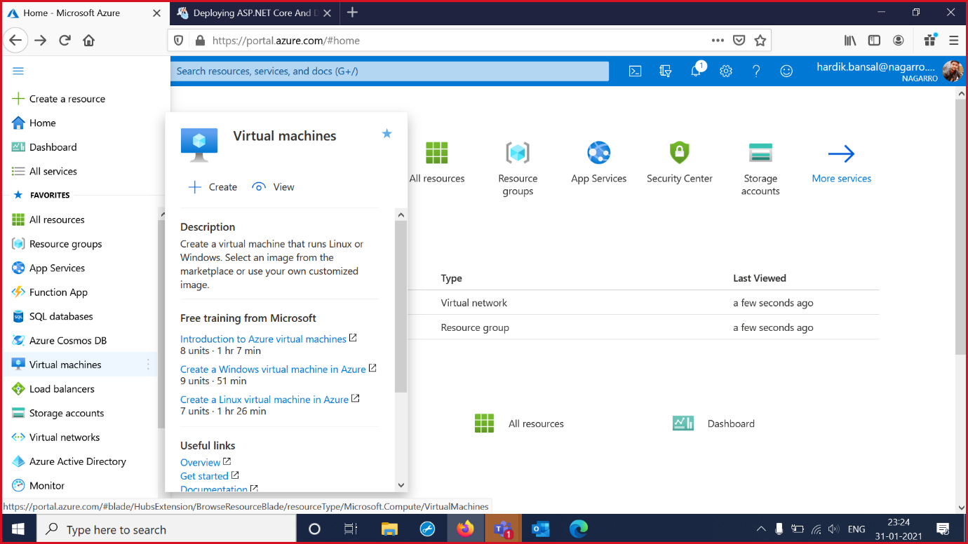

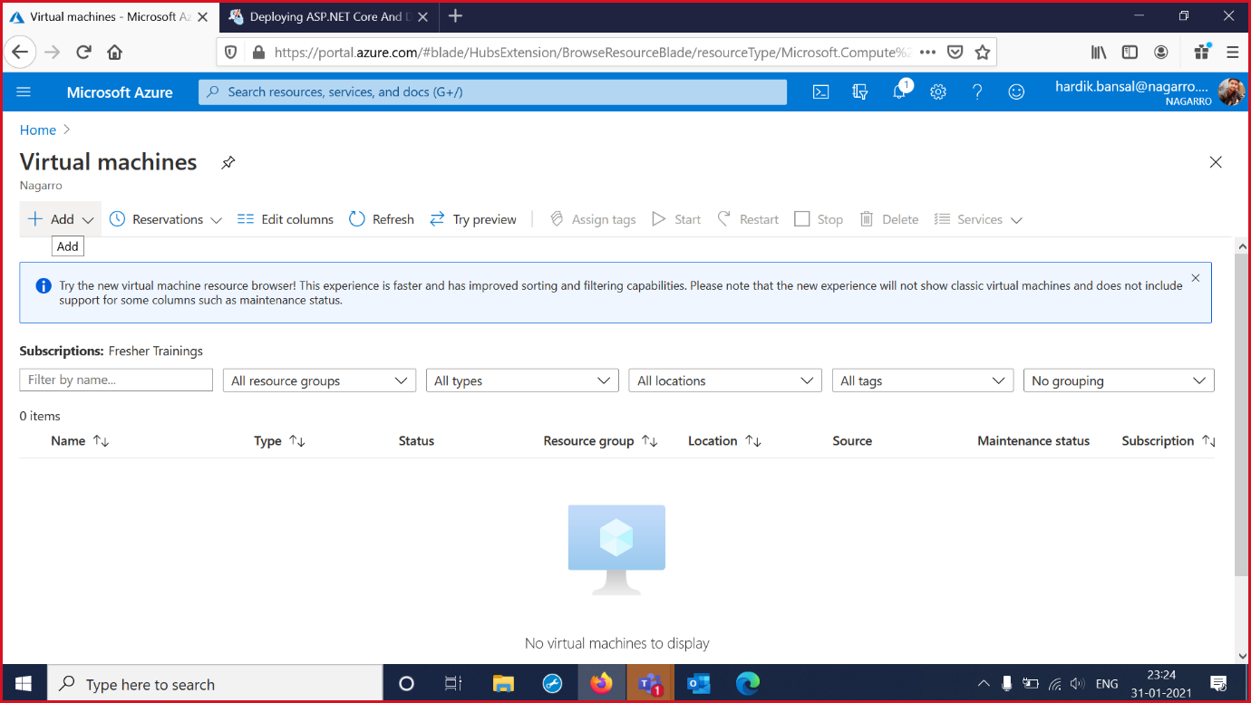

2.Select Resource Group and Virtual Machine Name and Region. Give Name and Password to the Machine . Take HTTP and RDP port in the Basics Tab.

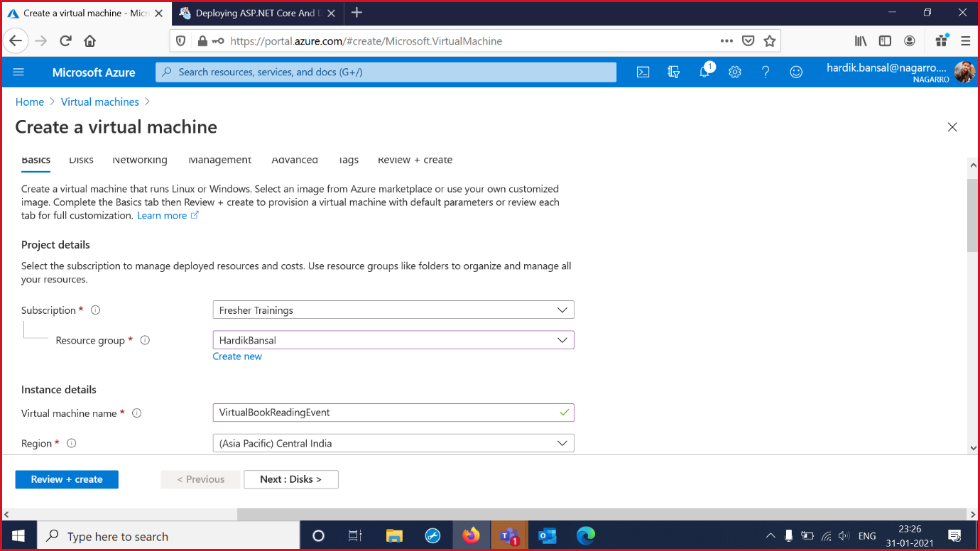

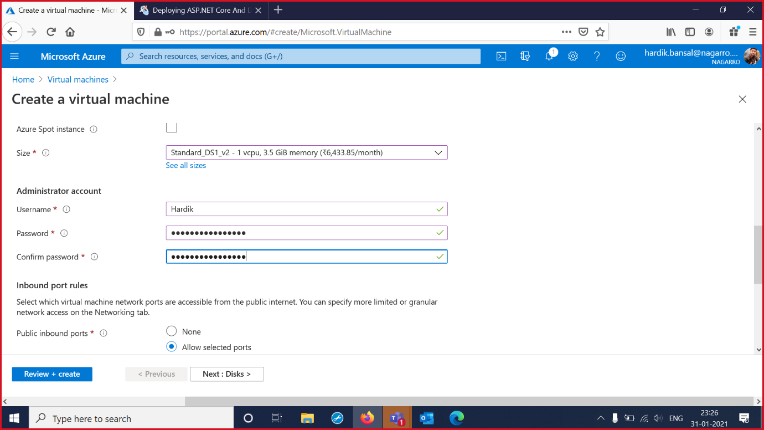

3. Select Review and Create then Check for the Validations Passes or not.

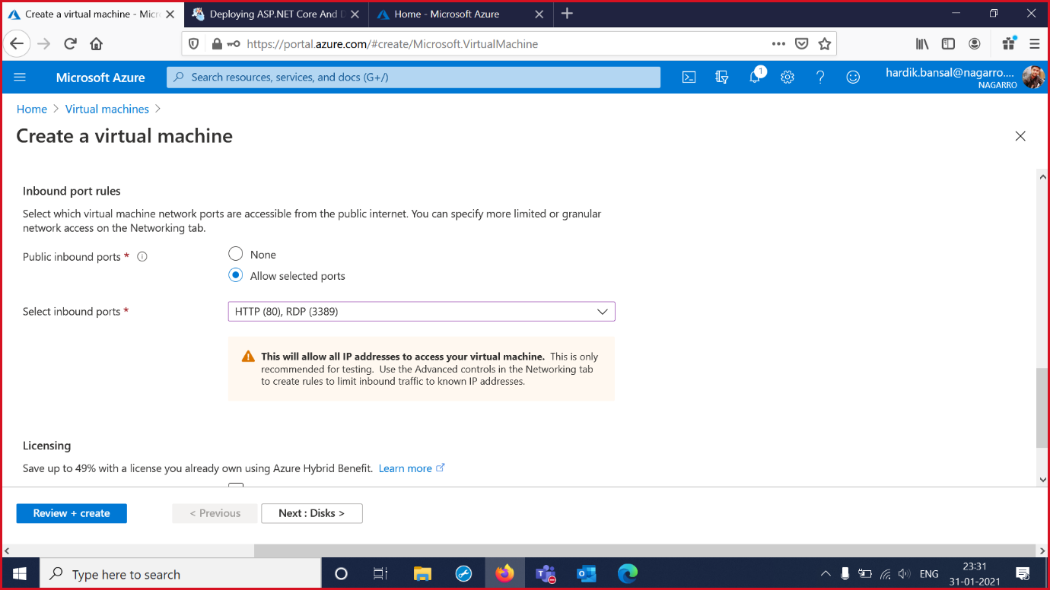

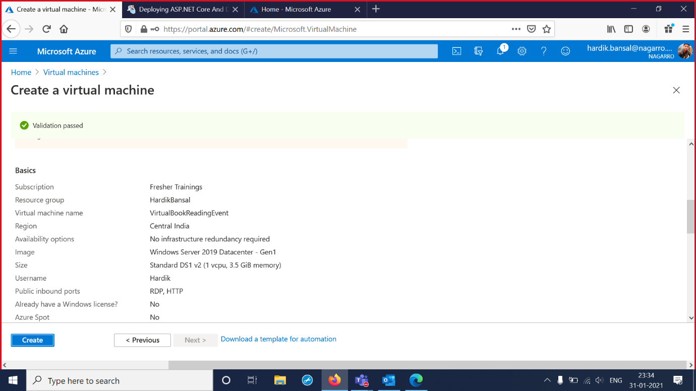

4.Virtual Machine is Deployed and Created.

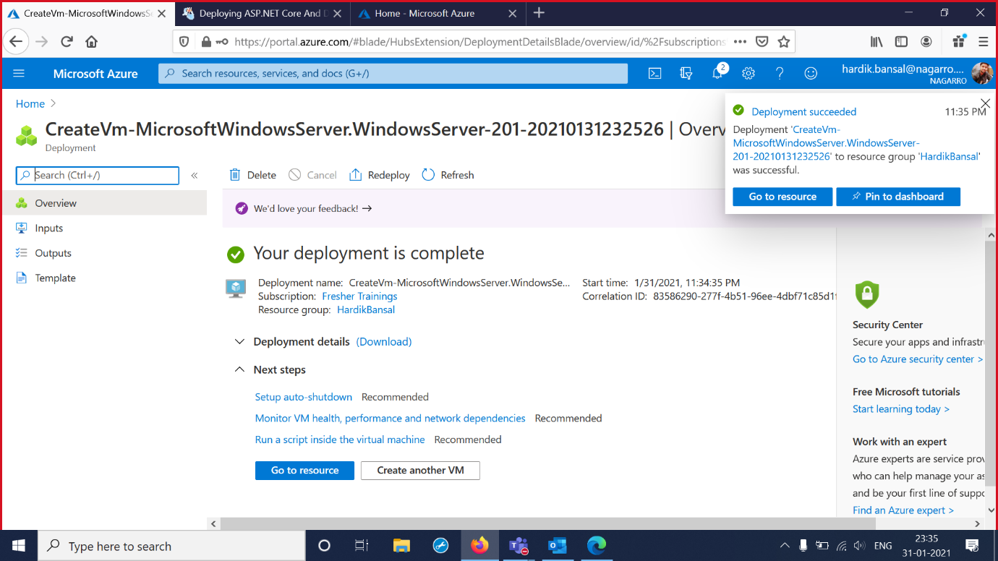

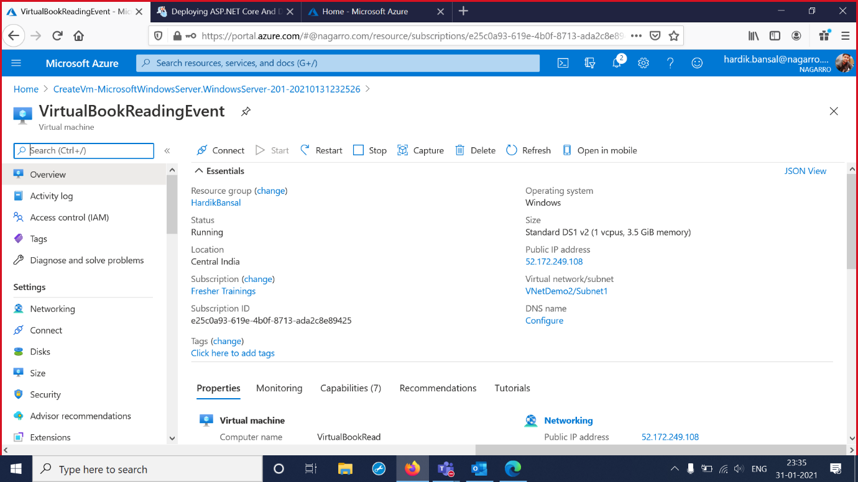

5.Connect to RDP and Download the RDP File.

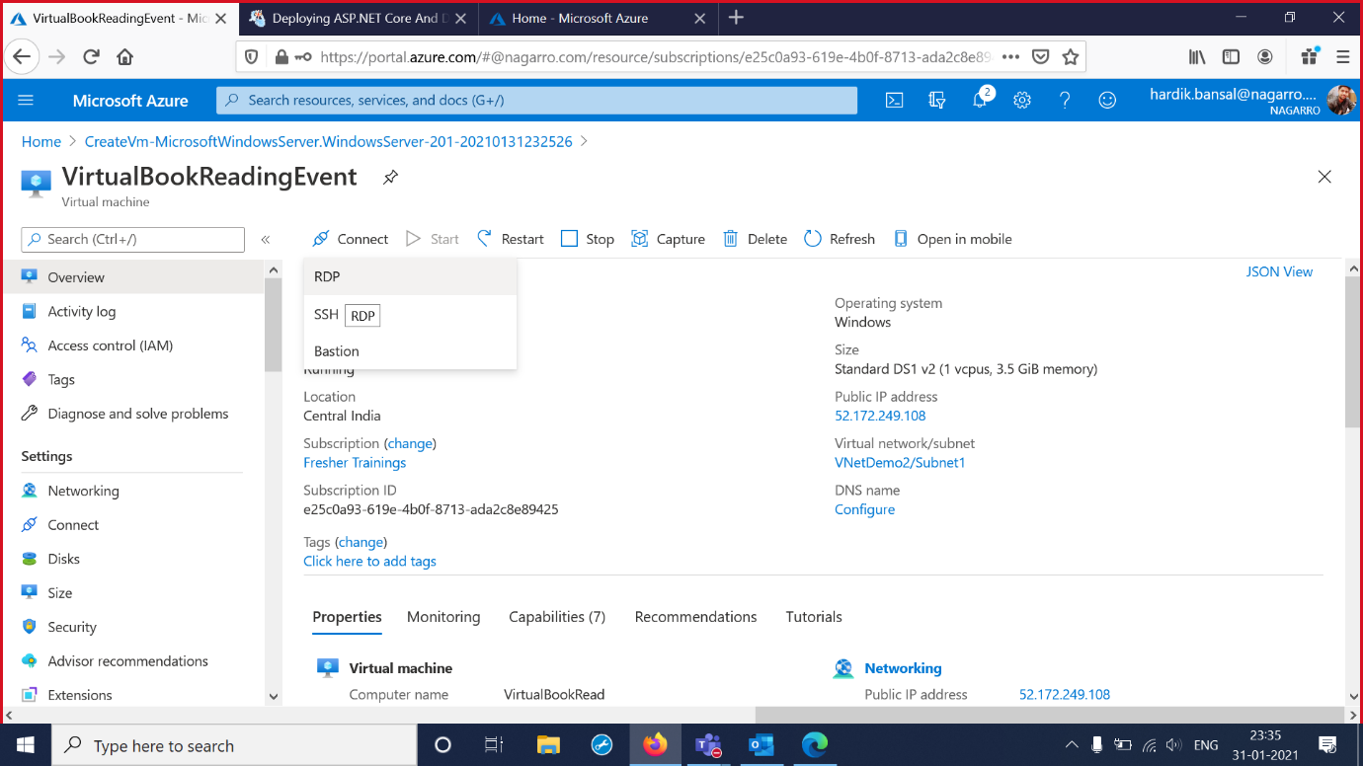

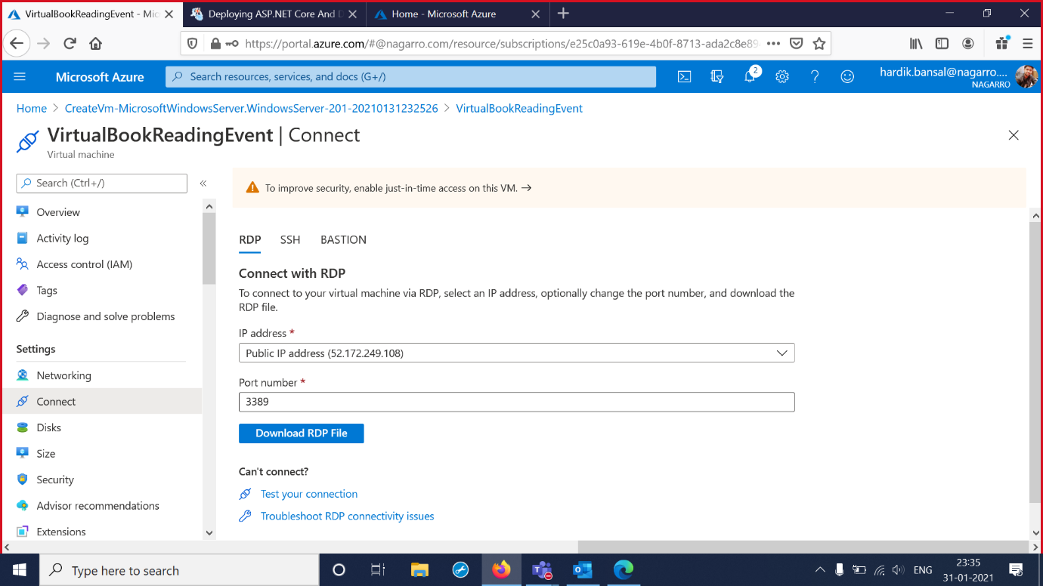

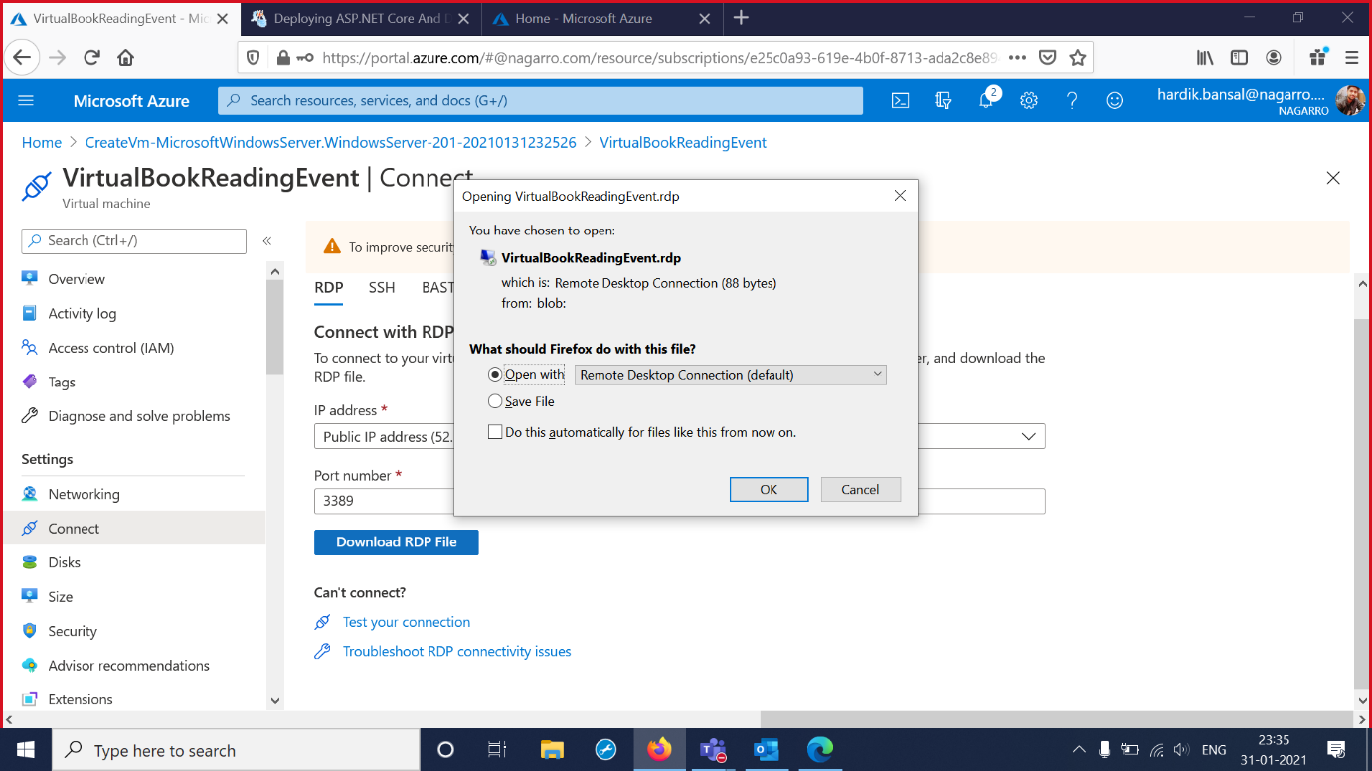

6.Open the Virtual Machine and Login with the VM credentials.

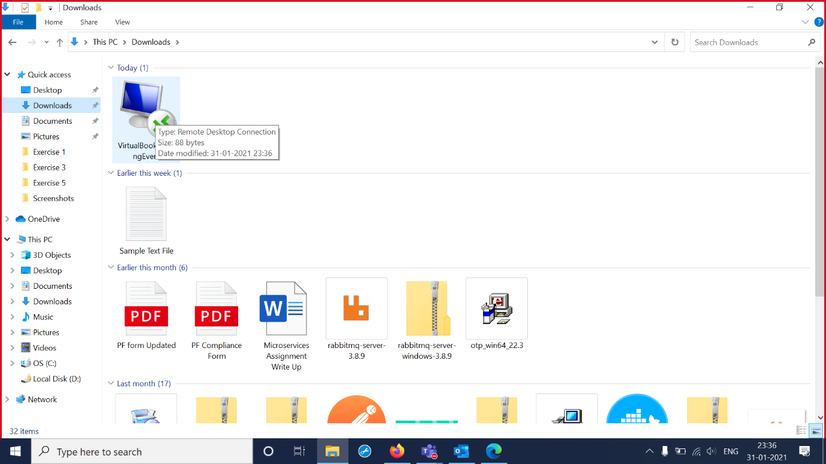

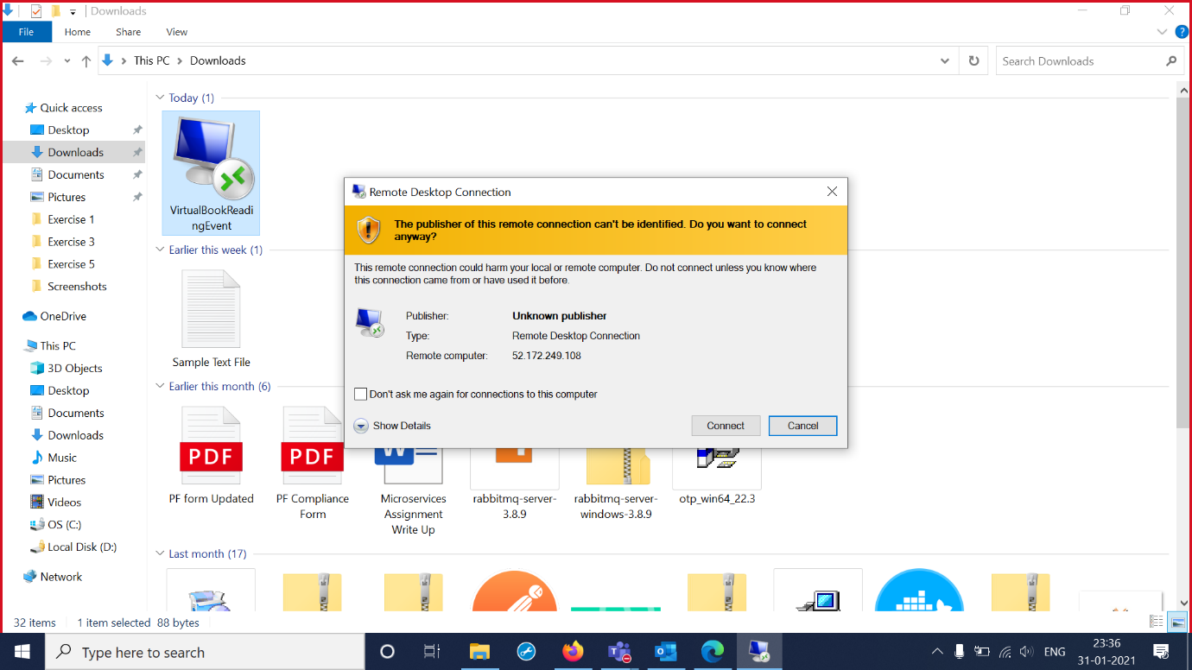

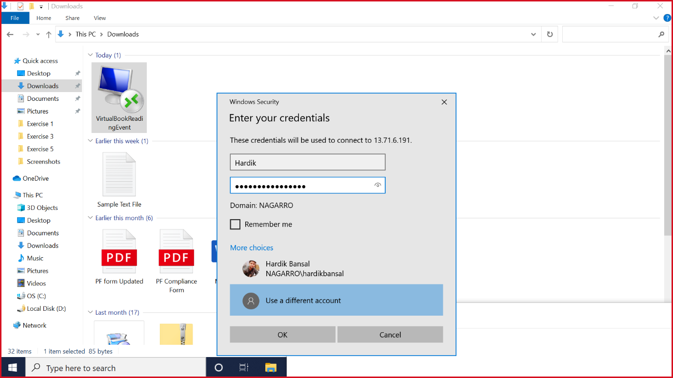

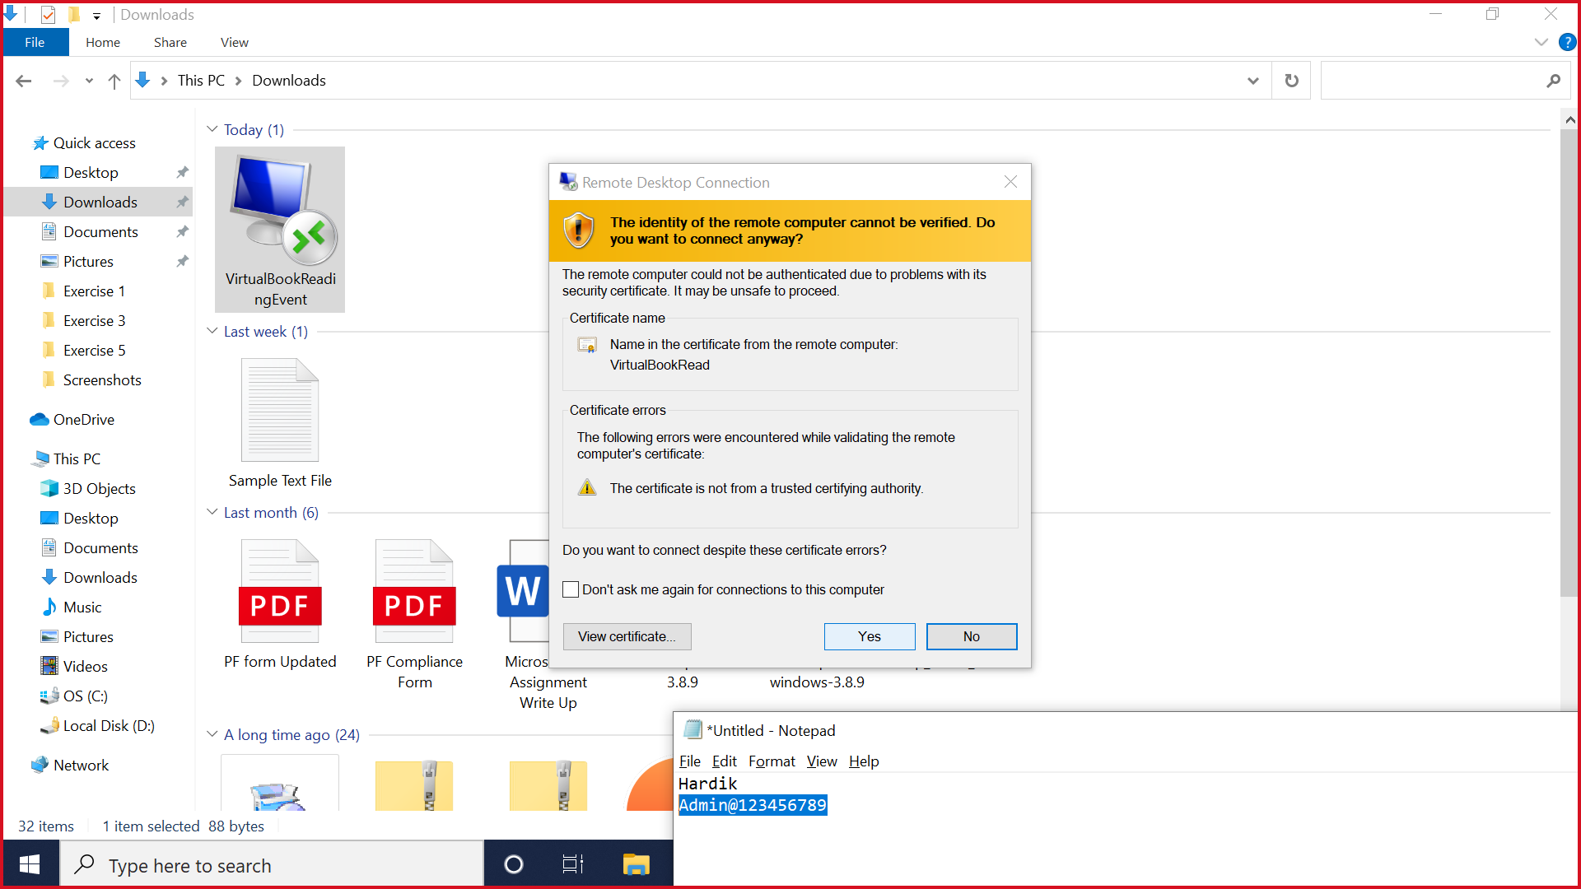

7.Virtual Machine is Created at IP 20.198.88.78

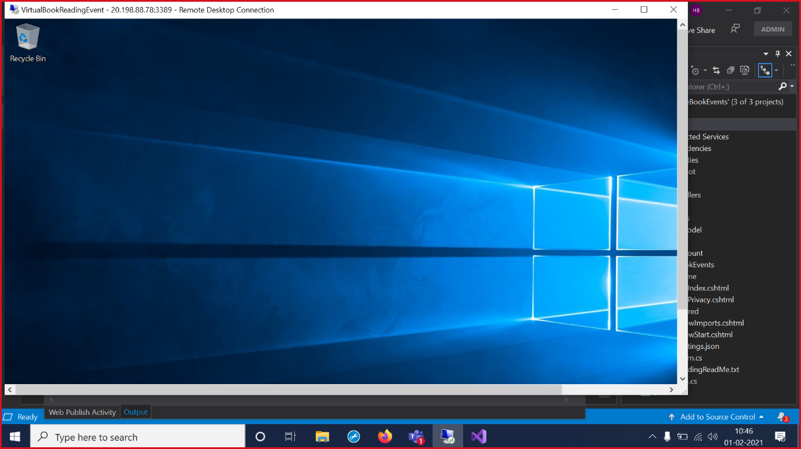

8. Add AppDeploy at port 8172 inbound port.

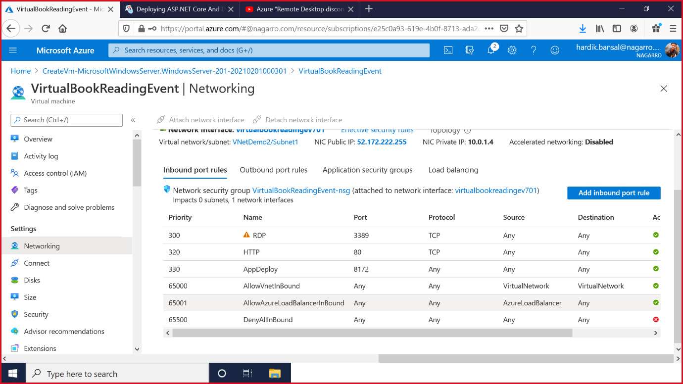

9.Now Publish using Visual Studio and Select Web Server and Follow the steps according to the successive images.

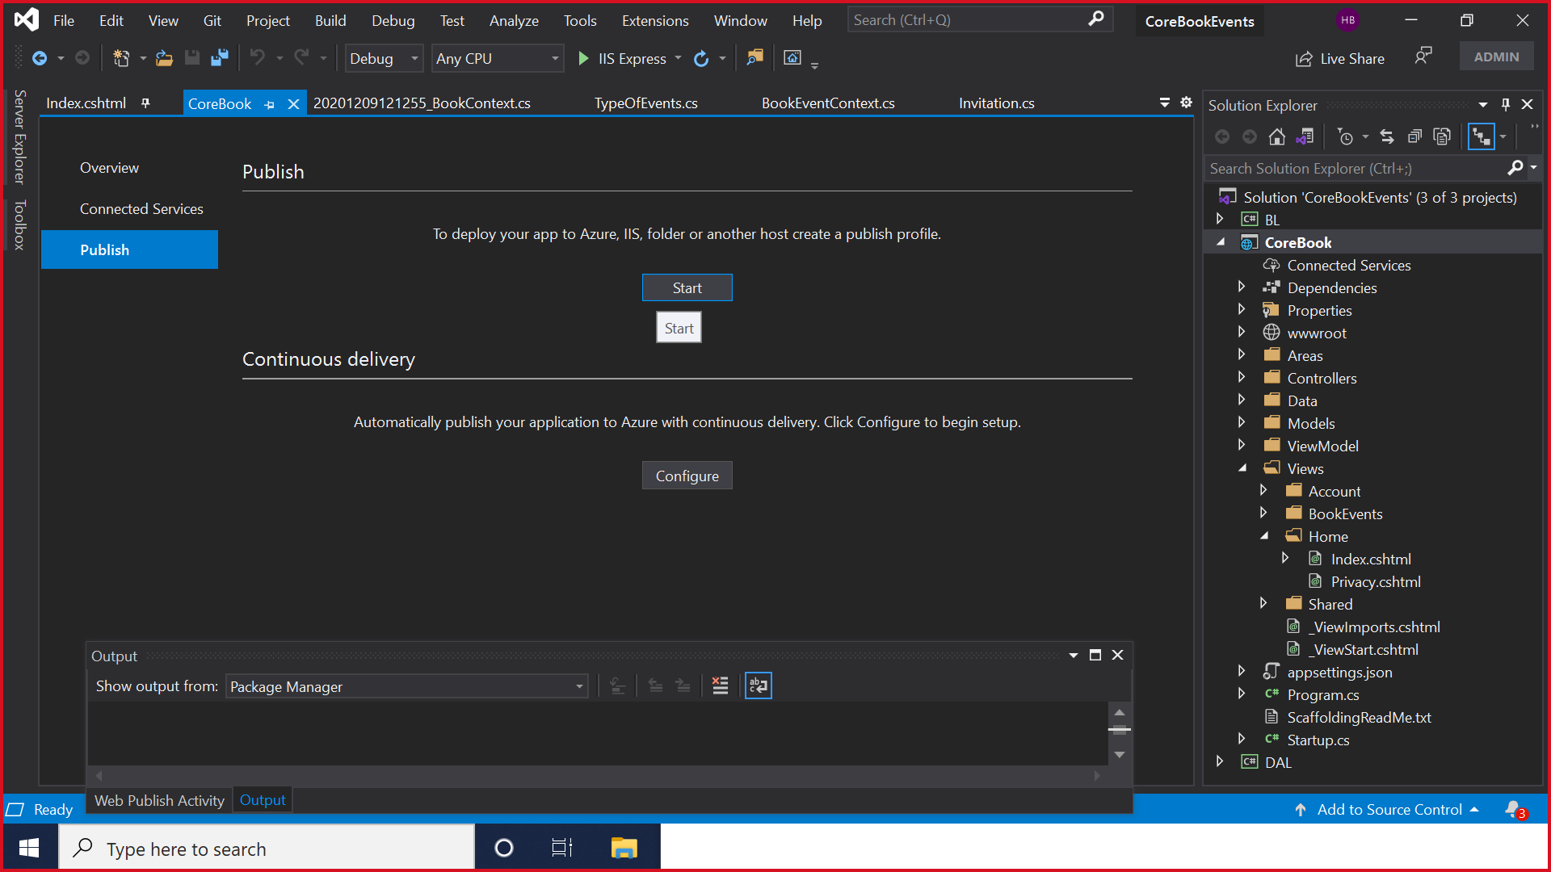

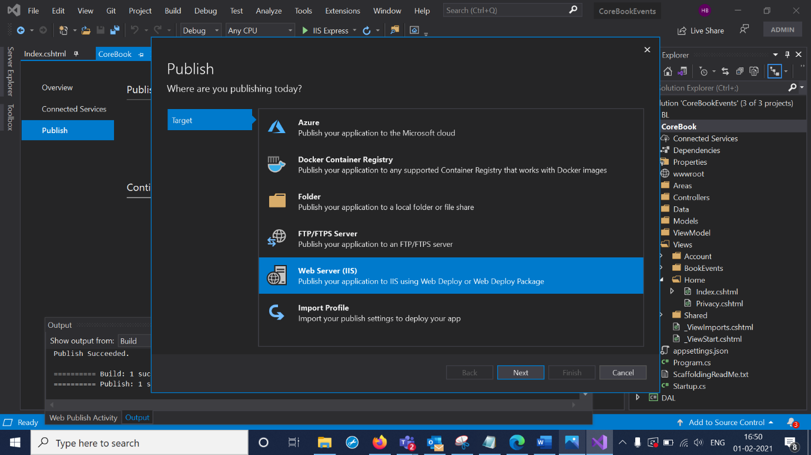

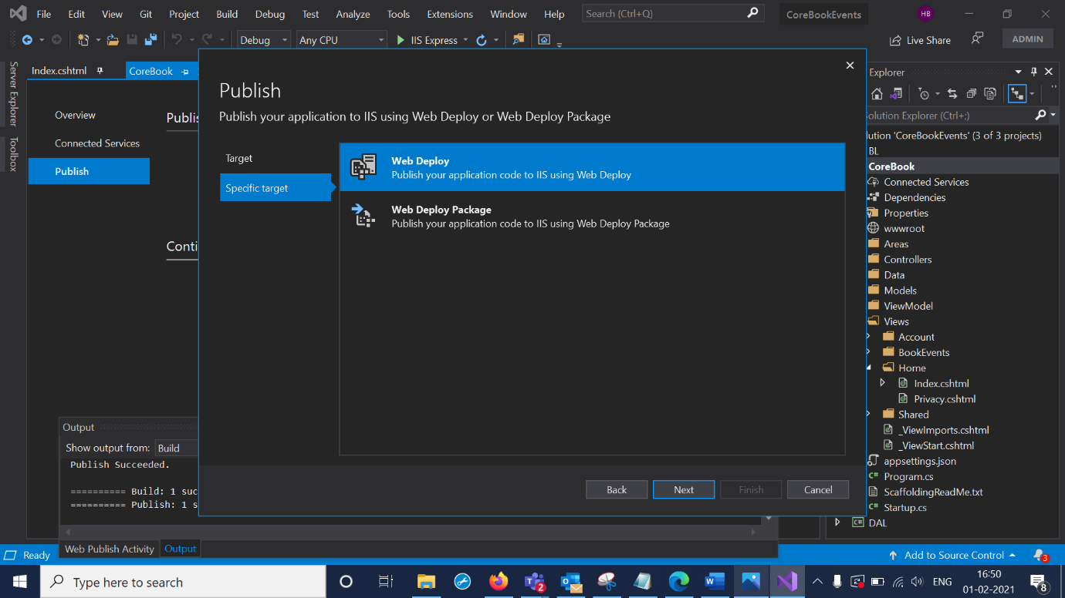

10.Add Virtual machine IP to the Server option and Add VM credentials into the username and password.

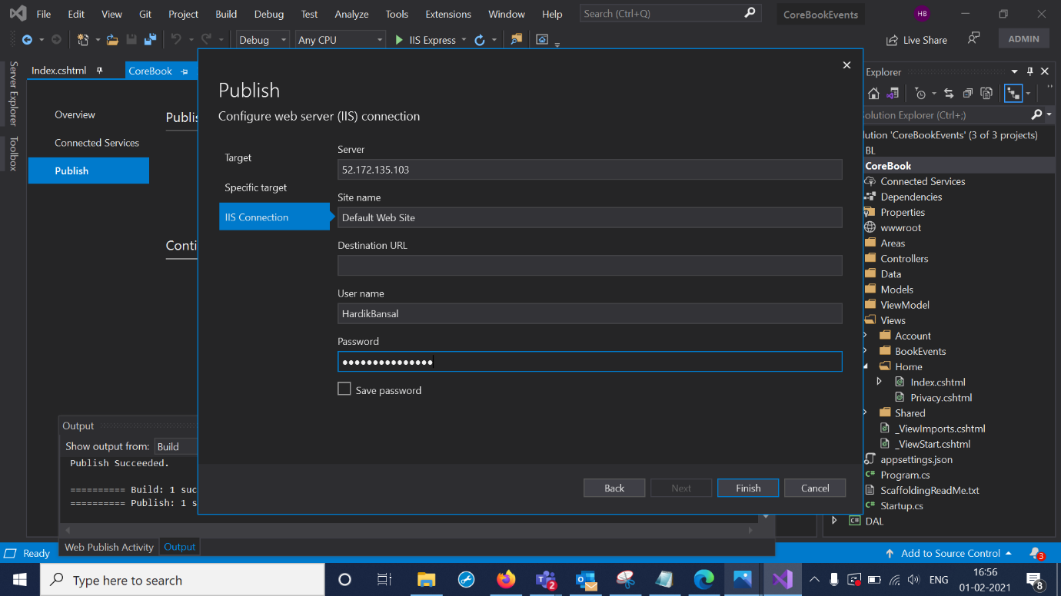

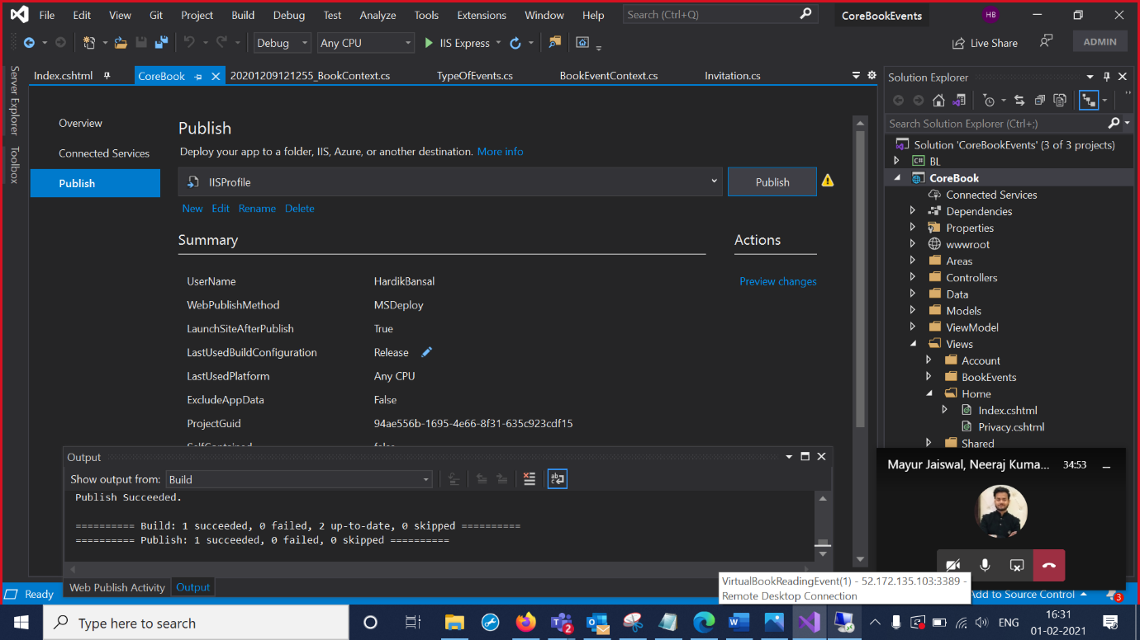

11.Select Edit and Use VM credential and press validate connections.Then select settings ,choose the existing database on the Azure portal.Publish the MVC

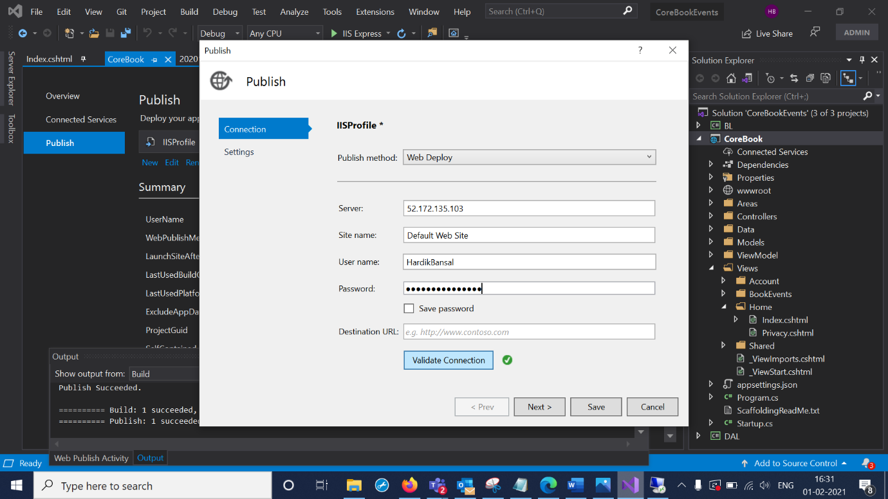

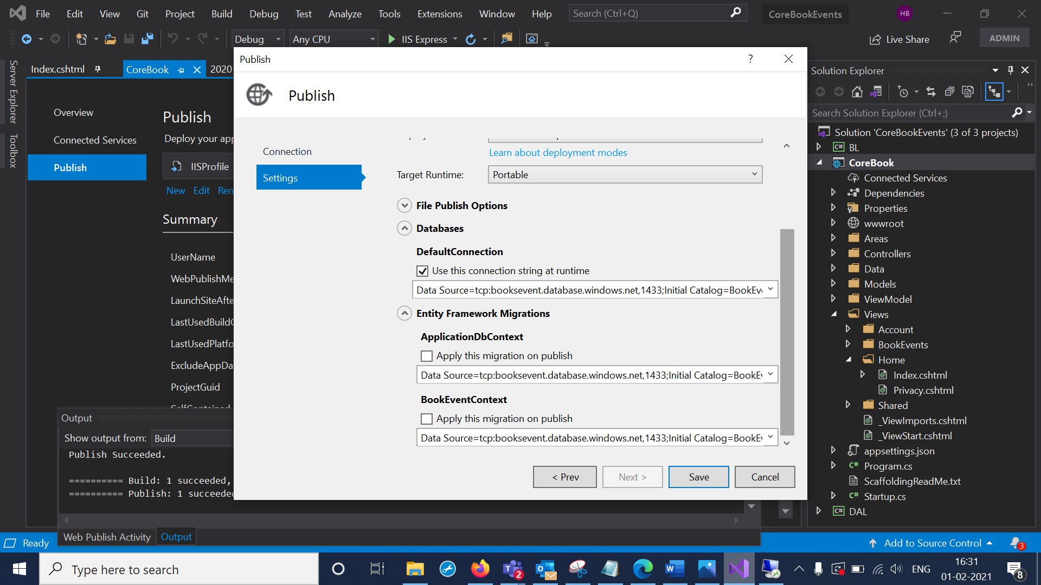

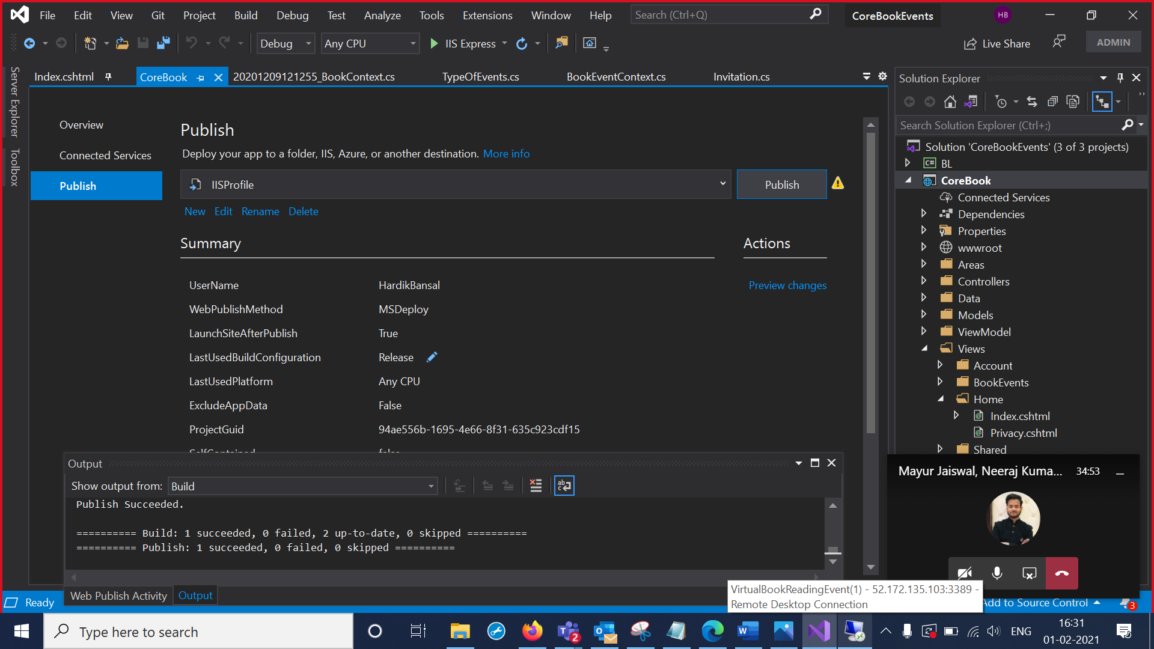

12. We downloaded Web Deploy software in the VM and checked the deployed MVC file

